COMMONWELTH OF MASSACHUSETTS

Rockingham, SS | Superior Court  Civil Action No.: 09-C-439

Charlene Gauvin  Plaintiff  vs.  Kendallwood Condominium Association, Cityside Management Corporation, and B&C Landscape  Defendant | )  )  )  )  )  )  )  ) | KEEPER OF RECORDS  NOTICE OF TAKING DEPOSITION

TO: | Peter Solomon, Esquire  Solomon Professional Associates  One Buttrick Road, P.O. Box 937  Londonderry, NH 03053 | Fred Desmarais, Jr., Esquire  Desmarais, Ewing & Johnston  175 Canal Street  Manchester, NH 03101

Please take notice that commencing at 10:00 a.m. on at Horn & Lauretti, 225 Friend Street, Suite 204 , Boston, MA 02114 the Defendant in this action by its attorney will take the deposition upon oral examination of the KEEPER OF RECORDS, The Orthopedic Center Anthony Marino, M.D., Medical Records, 17 Riverside Street, Suite 101 , Nashua, NH 03062 pursuant to Rule 30 of the Massachusetts Rules of Civil Procedure before a Notary Public, in and for the Commonwealth of Massachusetts, or before some other officer authorized by law to administer oaths. The oral examination will continue from day to day until completed. You are invited to attend and cross-examine.

Pursuant to M.G.L. Ch. 111, S. 70, as Amended by Chapter 158 of the Acts of 1990, this subpoena may be performed by mailing a certified copy on or before the date specified above to Axiom Requisition Copy Service, 447 North Canal Road, Lansing, MI 48917. YOU NEED NOT APPEAR IN PERSON. The Deponent is requested to forward the following: SEE ATTACHED SCHEDULE "A".
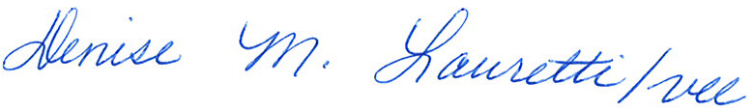

_______________________________________
Denise M. Lauretti, Esquire
Horn & Lauretti
225 Friend Street, Suite 204
Boston, MA 02114
Tel.: (617) 589-3000
Dated:

Order No. 01-18863-001

